#### A PROJECT REPORT ON

**“Coronavirus Probability Detector”**

Submitted in partial fulfilment of University of Mumbai for

Mini Project In

#### ANDROID APP DEVELOPMENT LAB

Submitted By

#### Ansari Abdurrahman

#### Firdaus Fauzan Khan

#### Gadkari Nihal Nasir

#### Khan Rutaab Ahmed

Supervisor **Prof. Tarannum Shaikh**



#### Department of Information Technology

M.H. SABOO SIDDIK COLLEGE OF ENGINEERING BYCULLA, MUMBAI – 400008.

UNIVERSITY OF MUMBAI

Academic Year 2020 – 2021



Department of Information Technology

M.H. Saboo Siddik College of Engineering

Byculla Mumbai-400008

### CERTIFICATE

This is to certify that the requirements for the report entitled “**Coronavirus Probability Detector**”have been successfully completed by the following students:

|  |  |
| --- | --- |
| **Rollno** | **Name** |
| 412005 | Ansari Abdurrahman |
| 412016 | Firdous Fauzan Khan |
| 412017 | Gadkari Nihal Nasir |
| 412033 | Khan Rutaab Ahmed |

in partial fulfilment of Mini Project in the Department of Information Technology, M.H Saboo Siddik College of Engineering, Byculla, Mumbai-400008.During the Academic Year 2020– 2021.

**Supervisor**

**(Prof. Tarannum Shaikh)**



Department of Information Technology

M.H. Saboo Siddik College of Engineering Byculla Mumbai-400008

#### PROJECT APPROVAL FOR

This project entitled **“Coronavirus Probability Detector”** by Ansari Abdurrahman, Firdaus Fauzan Khan, Gadkari Nihal Nasir, and Khan Rutaab Ahmed are approved for the degree of Bachelor of Engineering in Information Technology.

Examiners:

1.

2.

3.

Date:

Place:



Department of Information Technology

M.H. Saboo Siddik College of Engineering Byculla Mumbai-400008

#### DECLARATION

We declare that this written submission for Mini Project entitled “**Coronavirus Probability Detector**” represent our ideas in our own words and where others' ideas or words have been included. We have adequately cited and referenced the original sources. We also declare that we have adhered to all principles of academic honesty and integrity and have not misrepresented or fabricated or falsified any ideas / data / fact / source in our submission. We understand that any violation of the above will cause for disciplinary action by institute and also evoke penal action from the sources which have not been properly cited or from whom prior permission have not been taken when needed.

**Project Group Members**

Date: Place:

Ansari Abdurrahman Firdaus Fauzan Khan _____ Gadkari Nihal Nasir

Khan Rutaab Ahmed

**CONTENT**

**ABSTRACT**

**ACKNOWLEDGEMENT**

**LIST OF FIGURES**

1. **INTRODUCTION**

1.1 Introduction

1.2 Motivation

1.3 Problem Statement

1.4 Mini Project Contribution.

1. **PROPOSED SYSTEM**

2.1 Algorithm and Process Design

2.2 Details of Software

2.3 Results

2.4 Conclusion and Future work

# Abstract

# There is a new public health crisis threatening the world with the emergence and spread of 2019 novel coronavirus (2019-nCoV). The virus originated in bats and was transmitted to humans through yet unknown intermediary animals in Wuhan, Hubei province, China in December 2019. The disease is transmitted by inhalation or contact with infected droplets and the incubation period ranges from 2 to 14 d. The symptoms are usually fever, body pain, cough, runny nose, sore throat, breathlessness, fatigue, malaise among others. So, we have built a project name “Corona Virus Probability Detector” which will take input for symptoms of corona virus and will give probability of corona virus for a specific person, we have built this program using Python and machine learning concepts.

# Acknowledgement

The idea of this website is to stop the transmission by prioritizing test and hence detecting the cases quickly. Data can be collected on the symptoms of covid-19.  In this the person will specify their symptoms and according to their symptoms it will detect the person’s probability of infecting by Covid-19.

This project is our team’s contribution to helping to analyse the probability of a person having the infection. Technologies that were made to convert information so that it can be accessible to computers are used to aid people and we can contribute to a social cause.

We would like to thank our professor Prof. Tarannum shaikh for helping us and guiding us with this project. He allowed us to work on this project.

## Introduction

# Introduction

Covid-19 has been proven very dangerous pandemic, in this perilous Environment it has become much difficult to take precautions and take care of ourselves from the infections looming around. And even if get we infected, we can’t handle things on our own we need to consult a doctor, in addition to it doctors spare their time for patients and try their best to save the millions of lives. What if their time consumption gets reduced so that they get more time to save more lives from covid-19 for which a special kind of detection is required. Taking this notion in consideration there are many applications and websites have been developed so that the doctors can save their precious time. Coronavirus Probability Detector is a Web Application Prototype built for doctors to find out whom to test for the infection first under a limited testing capacity by finding out the probability of a person having the infection.

## 1.2 Motivation

Being a student it's a huge privilege of attempting to solve the

problem statement, and all of us (team members) have set our

path to accomplish it.

Working together for getting the solution, itself give us courage

to take more steps ahead and moving towards the achievement.

In addition to it Helpfulness and creative ideas make the contribution

to our experience as well as to the insights of getting successful.

If we succeed then we'll get much more insatiable for undertaking

such projects further in our lives.

Up till now we've learned that unity is strength, and togetherness

makes the success unstoppable.

Being youth it’s our duty to help our nation to protect all of us

from such pandemic. it’s obvious that we can’t save lives of people

as doctors do, but certainly we can contribute our efforts to make

their tasks facilitated. Working together for such a contribution

is honor for us and we’ll try our best to fulfill our oath.

## 1.3 Problem Statement

The detection of coronavirus is hot off the press since last year and

it's still on-going. Great engineers and software developers are

putting in their efforts to create something virtually which can help

doctors detect the probability of spread of infection for individual.

In such a situation we thought of developing a website which can assist

in the detection of covid-19.

despite of development of applications, websites still there's a dearth

of testing facilities for covid-19. Website which has been developed by

us for detection purpose is named as “**coronavirus probability detector**”

which shows the probability of the infectious spread of coronavirus

once the details such as body temperature, symptoms, etc. are entered

hence the detection of covid-19 can be done.

## 1.4 Mini Project Contribution

The proposed system is a covid-19 probability detector website in which the user can enter information about symptoms of corona virus like value of body fever, age, body pain, whether having runny nose or not, breathing difficulty. Based on such symptoms the website will show the probability for a person to have corona virus. Then based on the probability the actual covid test of person can be done by hospital department. So, it will become easier to check all the persons for corona virus.

**2. PROPOSED SYSTEM**

## 2.1 Algorithm and Process Design

Some important programs such as Training, Web development and Main Activity codes are given below.

#### Main Activity:

#### 

#### Training:

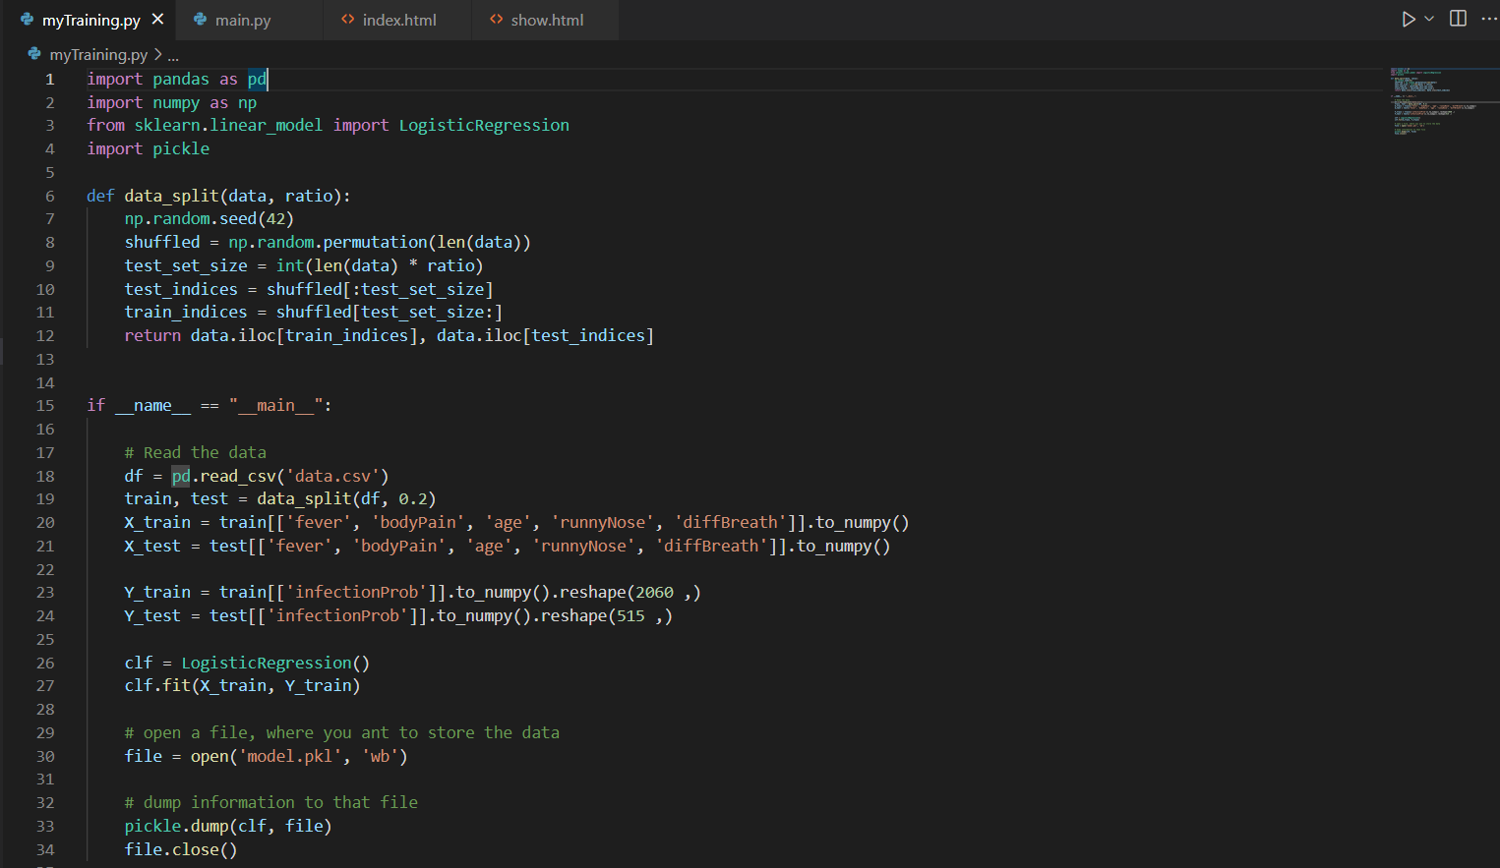

#### Web development:

#### 

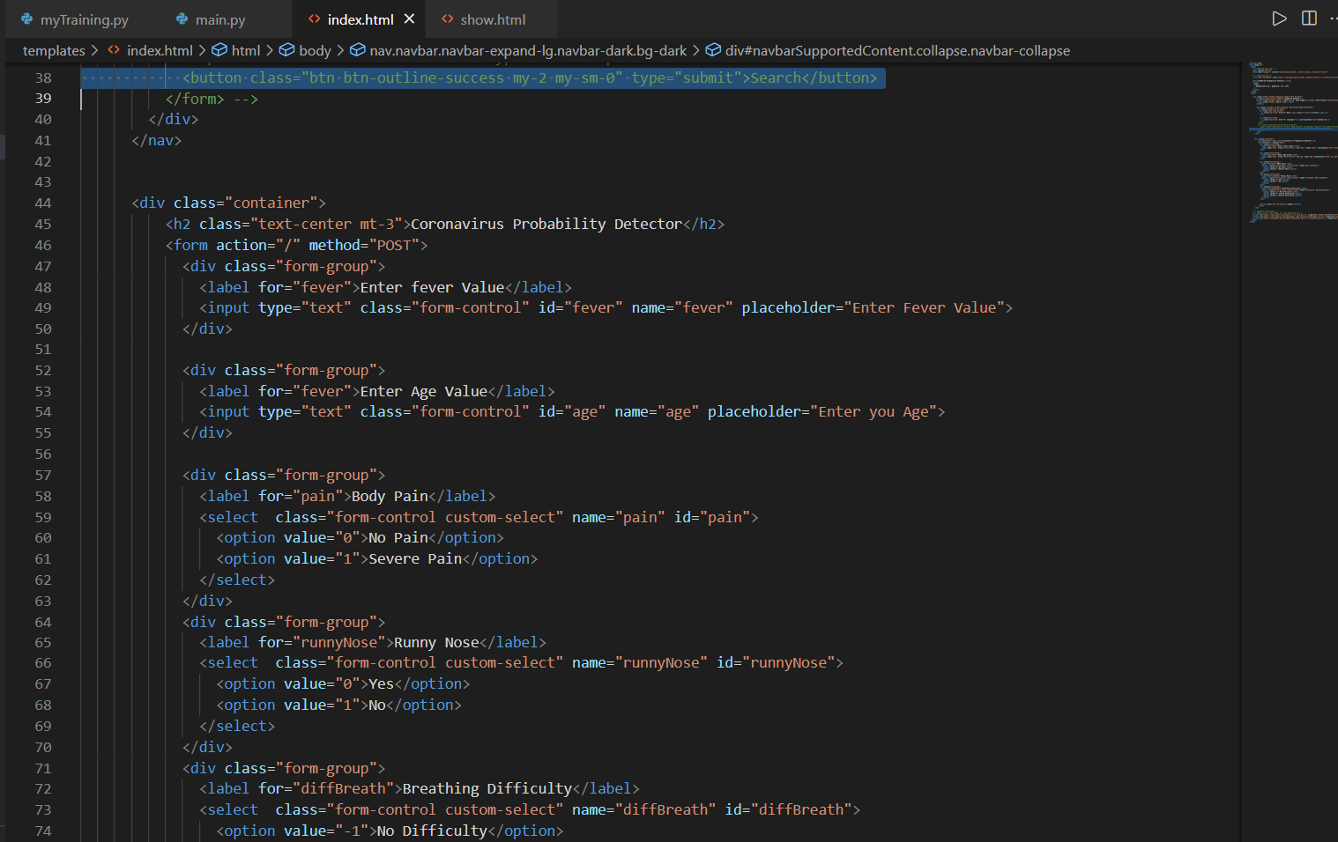

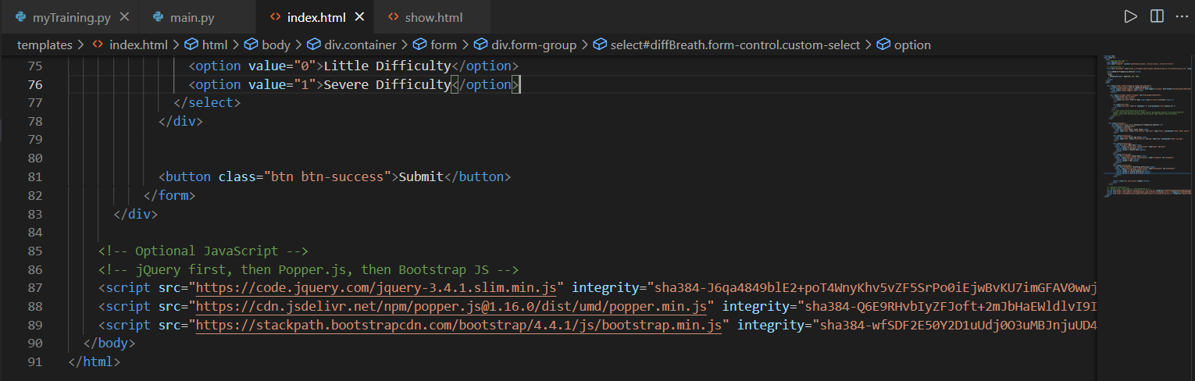

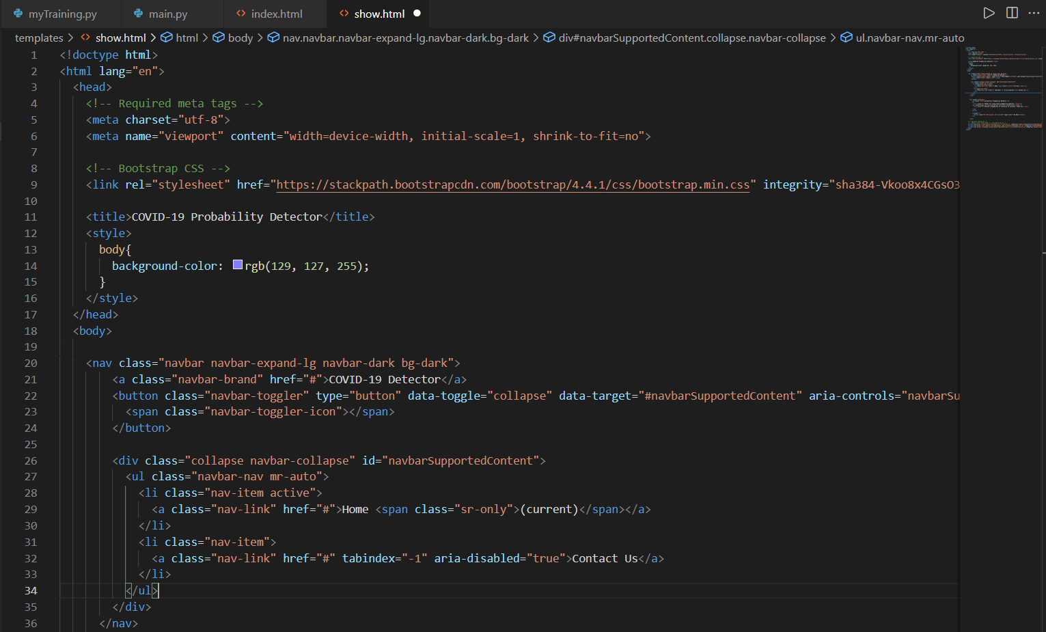

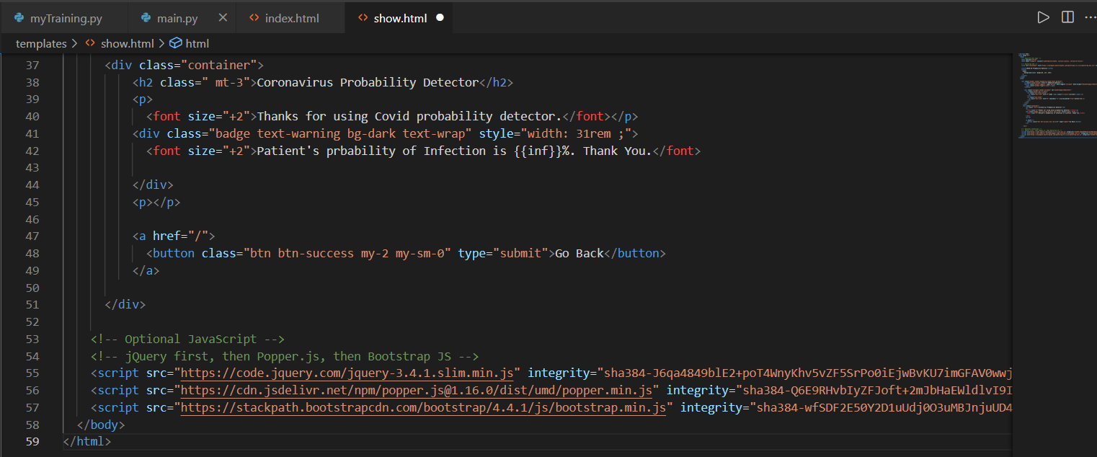

## 2.2 Details of Software:

## a. Coding Language:

## -->Python

## -->HTML

## b. Framework:

## -->Flask

## c. External Tools:

## -->NumPy

## -->Pandas

## -->Sklearn

## -->Pickle

**2.3 Results:**

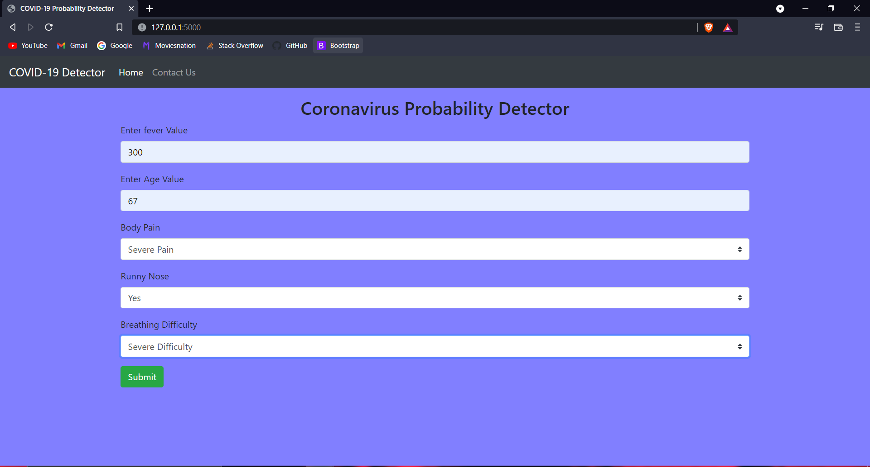

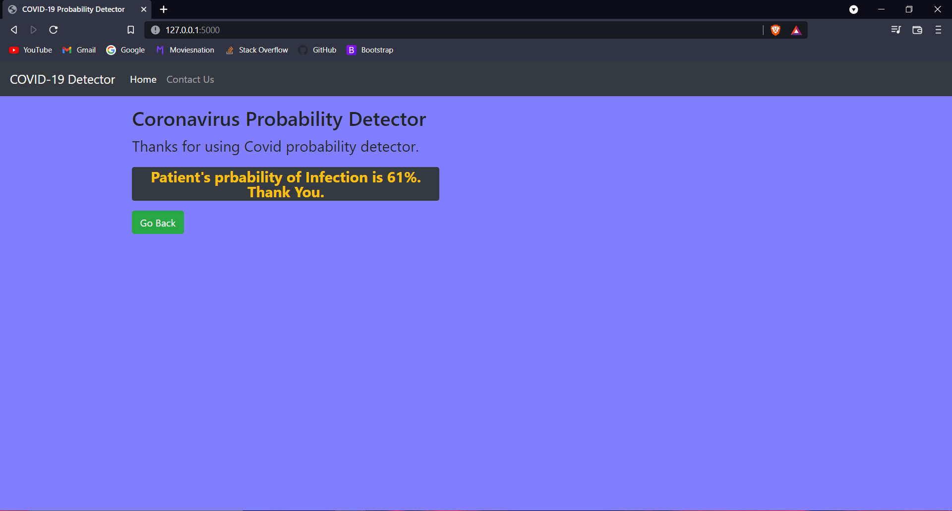

**2.4 Conclusion and Future Scope:**

**Conclusion:**

This website enables the user to put their details and get probability

of coronavirus. The probability helps the user to get an idea of how

much is the infection has spread throughout the body. Hence the

further precautions or actions can be taken according to that.

**Future Scope:**

We will consult a special team of doctors so that we may get to know more about covid-19 symptoms, on the basis of their suggestion we'll

edit our project and add more options based on new concepts.

We'll try to make our project user-friendly. We’ll make interface of advanced level so that, the one who uses may get the inputs filled easily.

We will improve our project from a mere website to an appropriate application and we'll try to add new and advanced features.

## 

## 

## 